Context Diagram: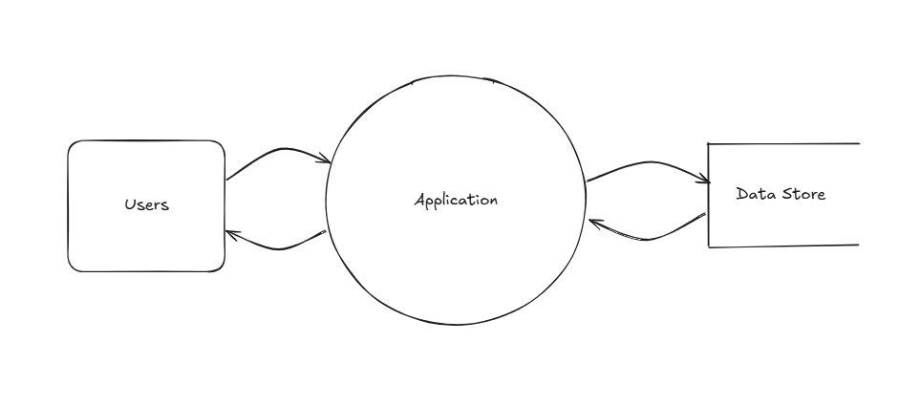

Data Flow Diagram:

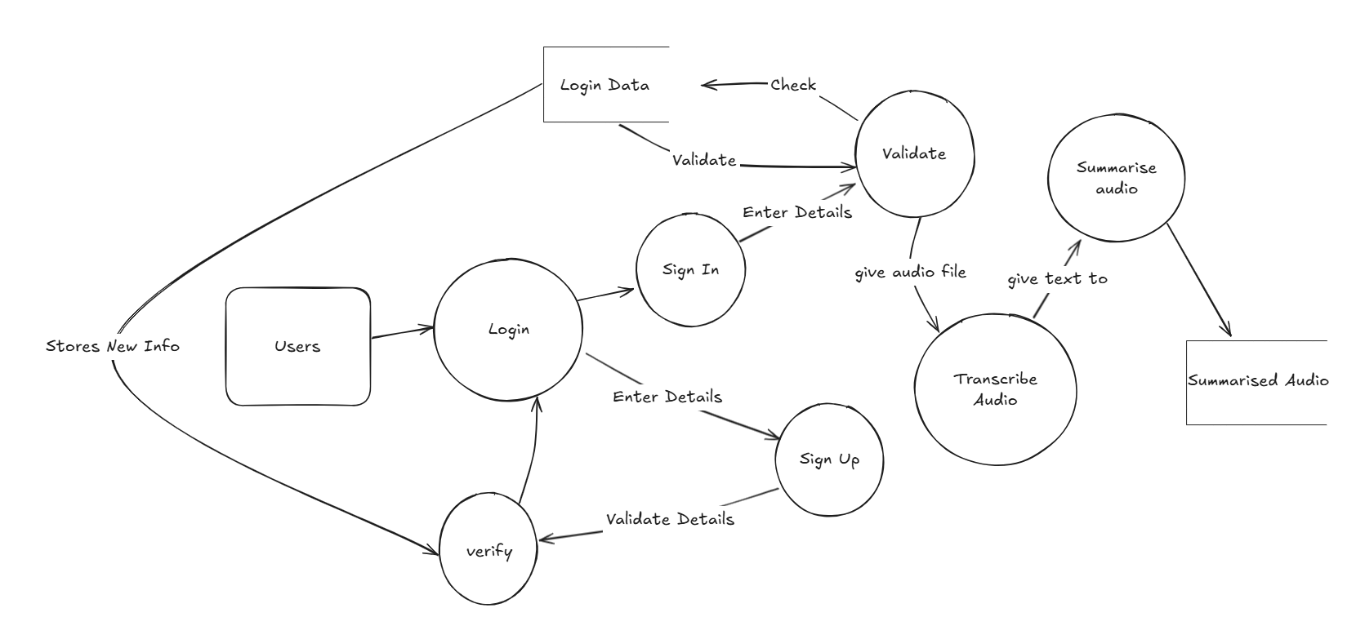

Data Dictionary:

| **Variable** | **Data Type** | **Format** | **Description** | **Example** | **Validation** |
| --- | --- | --- | --- | --- | --- |
| Username | String | Alphanumeric | Username of unique customer | DanielHay1 | Maximum 15 alphanumeric characters, cannot be blank |
| Password | String | Hashed Value | User’s secret details used for login | PassWord21 | Mixture of letters and numbers, must be more than 5 characters and less than 10 |
| UserId | Int | Not Displayed | Automatically attributed value for identification | 523453 | Unique, 6 Digit Number |
| AudioName | String | Alphanumeric | Users given name for uploaded audio | MathLecture6 | Alphanumeric, can't be null |
| Transcription | String | Alphanumeric | Text automatically created from given audio file | Today guys we'll be learning about mathematics | Text only, cannot be blank |
| Summary | String | Alphanumeric | Summary of text from transcription | Formula for triangle: ½ base x height  Formula for square: side^2 | Text only, cannot be blank |
| Tags | String | Alphanumeric | User given information tags for each audio summary | Mathematics  Mr Garry Lecture | Text only, cannot be blank |
| Date | Date and Time | YYYY/MM/DD | Date and time given when user inputs audio file | 20/05/2025 | Must be a valid date |